**Experiment No: 05**

**Name of the Experiment:** Study of Secant Method to Obtain the Root(s) of a Nonlinear Equation.

**Objectives:** The objective of this experiment is to apply Secant method to find out the very precise value of the root of an equation, using MATLAB.

**Theory:** x0 and x1 are two initial approximations for the root (s) of f(x) = 0 and f(x0) & f(x1) respectively, are their function values. If x2 is the point of intersection of x-axis and the line-joining the points (x0, f(x0)) and (x1, f(x1)) then x2 is closer to 's' than x0 and x1[1].

x2=  x1 - f(x1) *[ (x1-x0)/ f(x1) - f(x0)]

or in general the iterative process can be written as

xi+1=  xi - f(xi) *[ (xi- xi-1 )/ f(xi) - f(xi-1)] i=1,2,3…

**Tool:** MATLAB Software

**Methodology:**

**(I) Algorithm:**

1. Start
2. Get values of x0, x1 and e  
   *Here x0 and x1 are the two initial guesses  
   e is the stopping criteria, absolute error or the desired degree of accuracy*
3. Compute f(x0) and f(x1)
4. Compute x2 = [x0*f(x1) – x1*f(x0)] / [f(x1) – f(x0)]
5. Test for accuracy of x2  
   If [ (x2 – x1)/x2 ] > e, *Here [ ] is used as modulus sign*  
   then assign x0 = x1 and x1 = x2  
   goto step 4  
   Else, goto step 6
6. Display the required root as x2.
7. Stop

**(II)Flowchart:**

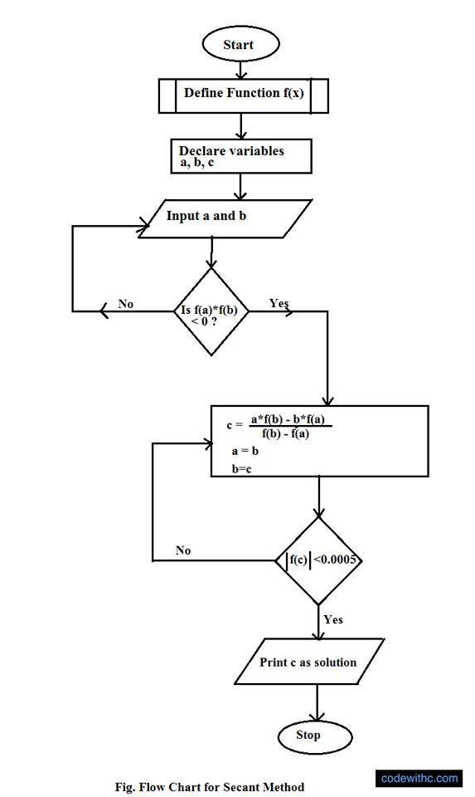

**Figure 2.1 Flowchart of secant method procedure [2]**

**(III) MATLAB Code:** The given function is f(x) =2x^2-15x+3

clear all

clc

syms x;

fun=input('Enter the fun:');

f=inline(fun);

while(1)

a=input('Enter the value of 1st assumption:');

b=input('Enter the value of 2nd assumption:');

if f(a)*f(b)>0

disp('Wrong');

elseif f(a)*f(b)<=0

break;

end

end

if f(a)==0

fprintf('Root')

return

elseif f(b)==0;

fprintf('Root')

return

end

display(' No. a b xn ')

display('---- ----- ----- ----- ')

for i=1:1:100

x=a-b;

z=f(a)-f(b);

xn=a-(x/z)*f(a);

if xn==a

break

else fprintf(' %d %f %f %f\n',i,a,b,xn);

end

b=a;

a=xn;

end

**Output:**

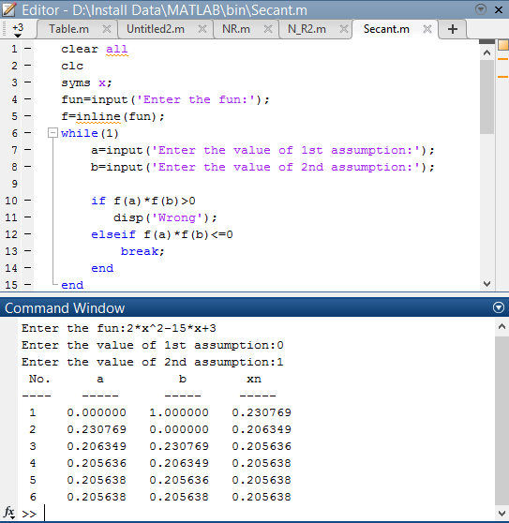

**Result& Discussion:** The roots of the given function is 0.205638.Which is equal to the original value (0.205638) directly calculated by calculator.

**Conclusion:** So from the above test we saw that nearly 6th iteration we get the resultant value of two roots which is very close to the original roots.

**References:**

[1]C. Chapra and P. Canale Raymond , “*Numerical Methods for Engineers”,* 7th ed. McGraw-Hill Education, 2 Penn Plaza, New York, NY 10121, 2015

[2]*Secant Method Algorithm and Flowchart,*CODEWITHC, April 21, 2014.Accessed on: Jan. 23,2020[online].

Available: <https://www.codewithc.com/secant-method-algorithm-flowchart/>